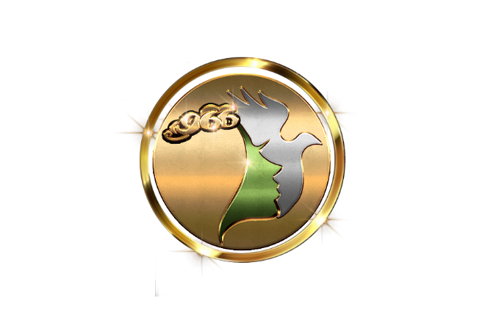

**WRITTEN FEEDBACK FORM**

|  |  |
| --- | --- |
| **LEARNER NAME:** |  |
| **ASSESSOR NAME:** |  |
| **UNIT TITLE** | UV30424 Provide body massage |

|  |
| --- |
| **ASSIGNMENT BRIEF:**  Outcome 1: Be able to prepare for body massage treatment  Outcome 2: Be able to provide a body massage treatment  Please use the unit content at the back of each unit for guidance to achieve the learning outcomes. All questions/activities/tasks must be answered thoroughly to understand the underpinning knowledge and skills to complete the unit. |

|  |
| --- |
| **ASSESSOR FEEDBACK:** |

|  |  |
| --- | --- |
| **ACTION PLAN:** | **TARGET DATE** |
|  |  |

|  |
| --- |
| **ASSESSOR SIGNATURE:** |

|  |
| --- |
| **LEARNER SIGNATURE:** |

**U30424 Provide body massage treatment**

**Outcome 1: Be able to prepare for body massage treatment**

1. **Describe salon requirements for preparing yourself, the client and work area**
2. **Describe the environmental conditions suitable for body massage treatments**
3. **Describe different consultation techniques used to identify treatment objectives**
4. **Describe how to select products, tools and equipment to suit client treatment needs, skin and nail conditions.**
5. **Describe different skin types and conditions**

|  |  |
| --- | --- |
| **SKIN TYPE** | **DESCRIPTION** |
| **NORMAL** |  |
| **OILY** |  |
| **DRY** |  |
| **SKIN CONDITION** | **DESCRIPTION** |
| **MATURE** |  |
| **SENSITIVE** |  |
| **DEHYDRATED** |  |

1. **Describe the contra-indications which prevent body massage treatments**

**PLEASE COMPLETE THE TABLES**

**Contra-indications that prevent:**

|  |  |
| --- | --- |
| **CONTRA-INDICATIONS** | **DESCRIPTION** |
| **DEEP VEIN THROMBOSIS** |  |
| **CHEMOTHERAPY/RADIOTHERAPY** |  |
| **IMPETIGO** |  |
| **HERPES SIMPLEX/ZOSTER** |  |
| **(FUNGAL) TINEA CORPORIS** |  |
| **CANCER** |  |
| **HYPERTENSION** |  |
| **HYPOTENSION** |  |
| **DIARRHOEA/VOMITING** | . |
| **HAEMOPHILLIA** |  |
| **MEDICAL OEDEMA** |  |
| **OSTEROPOROSIS** |  |
| **FEVER** |  |
| **RECENT OPERATIONS** |  |
| **PSYCHOSIS** |  |
| **PREGNANCY** |  |
| **SEVERE VARICOSE VEINS** |  |
| **RECENT HEAD AND NECK INJURY** |  |
| **HAEMORRHAGE** |  |
| **MENINGITIS** |  |
| **NERVOUS SYSTEM DISORDERS** |  |
| **UNDIAGNOSED LUMPS/PAIN** |  |
| **MEDICATION** |  |

**Contra-indications that restrict:**

|  |  |
| --- | --- |
| **CONTRA-INDICATIONS** | **DESCRIPTION** |
| **DIABETES** |  |
| **VARICOSE VEINS** |  |
| **HIGH/LOW BLOOD PRESSURE** |  |
| **PRODUCT ALLERGIES** |  |
| **BOILS/FOLLICULITIS** |  |
| **WARTS/VERRUCA** |  |
| **TINEA PEDIS** |  |
| **DRUGS/ALCOHOL** |  |
| **CUTS/ABRASIONS** |  |
| **SWELLING** |  |
| **RECENT SCAR TISSUE** |  |
| **ECZEMA/PSORIASIS** |  |
| **MENSTRATION** |  |
| **HERNIA** |  |
| **HEAVY MEAL** |  |
| **ASTHMA** |  |
| **SUNBURN** |  |
| **MIGRAINE** |  |

1. **State the objectives of massage treatments**
2. **State the benefits derived from massage treatments**
3. **Identify general body types:**

|  |  |
| --- | --- |
| **BODY TYPES:** | **DESCRIPTION** |
| **ECTOMORPH** |  |
| **ENDOMORPH** |  |
| **MESOMORPH** |  |

1. **Describe the different types of body fat**

|  |  |
| --- | --- |
| **BODY FAT** | **DESCRIPTION** |
| **WHITE FAT** |  |
| **BROWN FAT** |  |
| **BEIGE FAT** |  |
| **ESSENTIAL FAT** |  |
| **SUBCUTANEOUS FAT** |  |
| **VISERAL FAT** |  |
| **GENDER VARIABLES** |  |
| **ETHNIC VARIABLES** |  |

1. **Outline common postural faults**

|  |  |
| --- | --- |
| **POSTURAL FAULTS** | **DESCRIPTION** |
| **KHYPHOSIS** |  |
| **LORDOSIS** |  |
| **SCOLIOSIS** |  |

**Outcome 2: Be able to provide a body massage treatment**

1. **Explain how to communicate and behave in a professional manner**
2. **Describe health and safety practices**
3. **Explain the importance of positioning yourself and the client correctly throughout the treatment**
4. **Explain the importance of using the correct products, tools, equipment and techniques to suit client treatment needs, skin and nail conditions**
5. **Describe the benefits and uses of mechanical massage and pre-heat treatments**
6. **Describe the different massage techniques and their benefits**
7. **State the contra-actions that may occur during and following treatments and how to respond**
8. **State the importance of completing the treatment to the satisfaction of the client**
9. **State the importance of completing treatment records**
10. **State the aftercare advice that should be provided**
11. **Describe the structure and the main functions of the following body systems in relation to massage skin, skeletal, muscular, cardiovascular, lymphatic, nervous, digestive, urinary and endocrine**

**THE SKIN:**

**EXPLAIN THE LAYERS AND FUNCTIONS OF SKIN:**

**LAYERS OF THE EPIDERMIS**

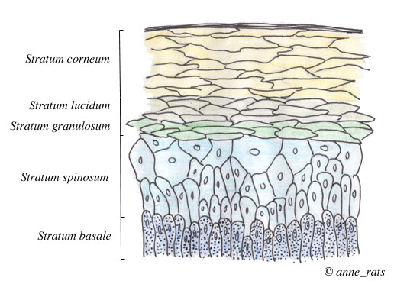

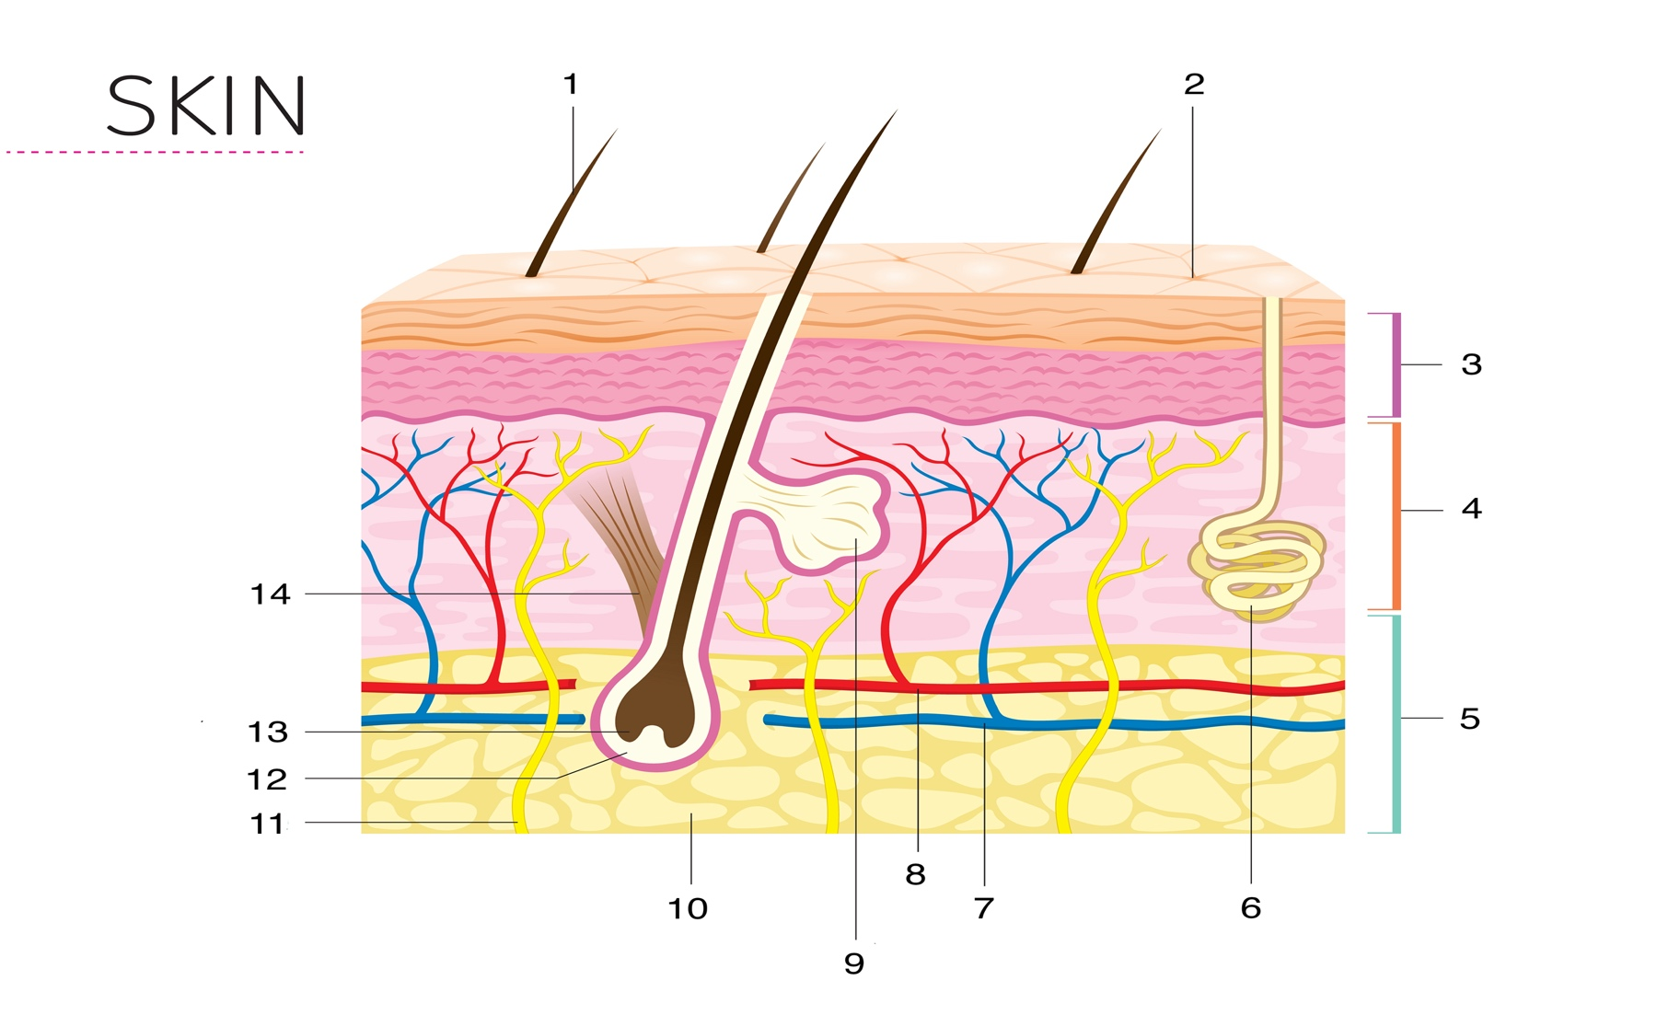

**7.**

**8.**

**THE MUSCULAR SYSTEM**

**WHAT IS A MUSCLE?**

**EXPLAIN THE STRUCTURE OF MUSCLE:**

**TYPES OF MUSCLES**

In the body, there are three types of [muscle](https://api.seer.cancer.gov/rest/glossary/latest/id/55a2f6a5e4b05cd0cdd944ea): skeletal (striated), smooth, and [cardiac](https://api.seer.cancer.gov/rest/glossary/latest/id/5522be3ce4b0bc5c16c045d7).

## Skeletal Muscle

## Smooth Muscle

## Cardiac Muscle

**FUNCTION OF MUSCLES**

|  |  |
| --- | --- |
| **MUSCLE FUNCTION** | **DESCRIPTION** |
| **CONTRACTION** |  |
| **RELAXATION** |  |
| **HEAT PRODUCTION** |  |
| **MOVEMENT** | |
| **FLEXION** |  |
| **EXTENSION** |  |
| **ABDUCTION** |  |
| **ADDUCTION** |  |
| **SUPINATION** |  |
| **PRONATION** |  |
| **ROTATION** |  |
| **CIRCUMDUCTION** |  |
| **INVERSION** |  |
| **EVERSION** |  |
| **PLANTARFLEXION** |  |
| **DORSIFLEXION** |  |

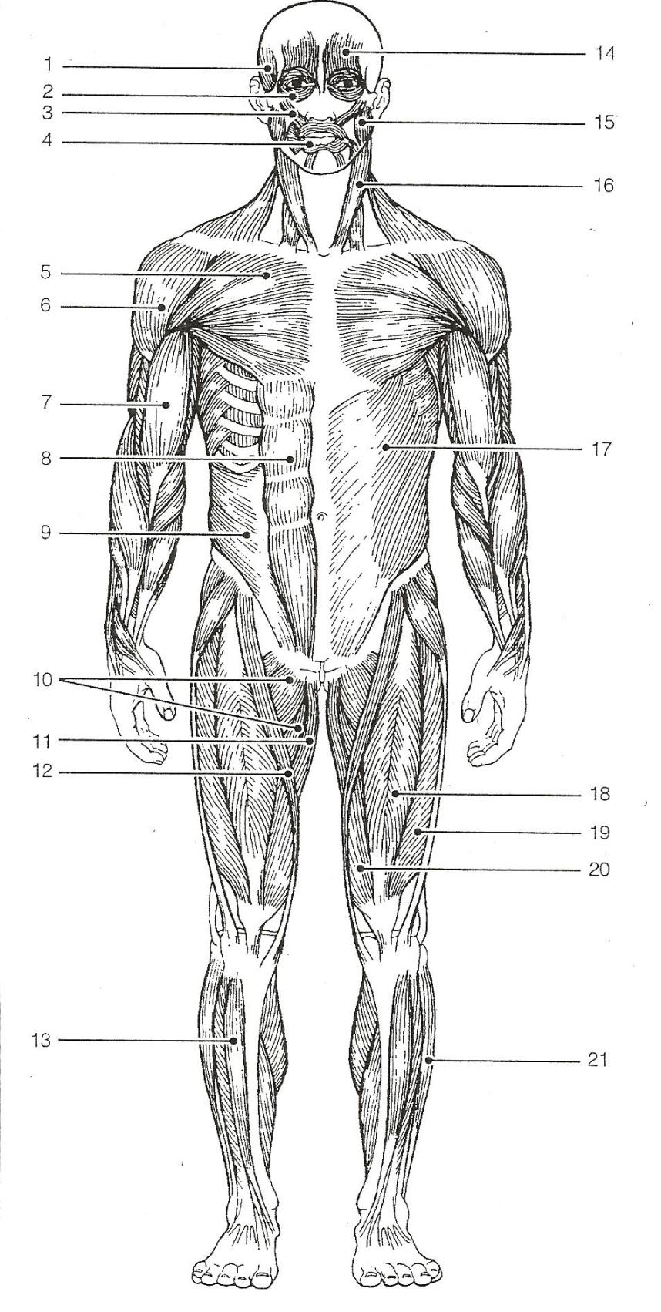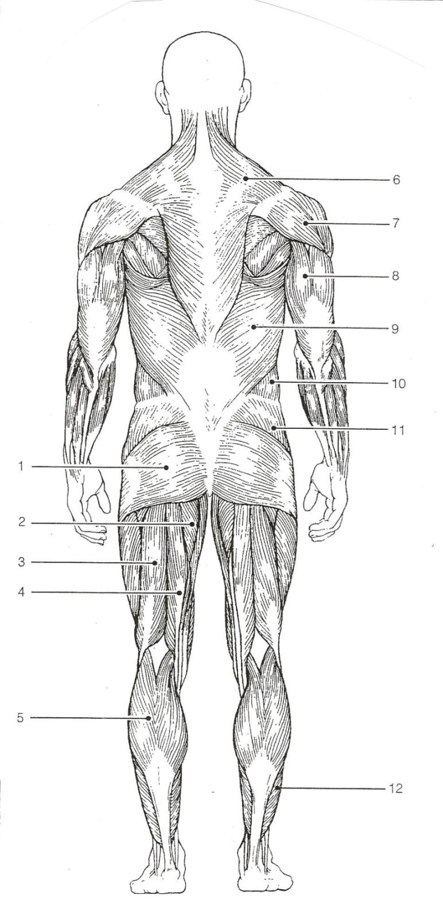

**DIAGRAM**

**SHOWING**

**MUSCLES OF THE BODY:**

**ANTERIOR AND**

**POSTERIOR**

**Muscle Man Diagrams Study Sheet** – Place the numbers on the diagram next to the correct muscle – Anterior & Posterior muscles are all in this same list. A (2) means they show up on both diagrams.

1. Adductors (2)
2. Biceps brachii
3. Biceps femoris
4. Deltoid (2)
5. External oblique (2)
6. Fibularis longus
7. Frontalis
8. Gastrocnemius
9. Gluteus maximus
10. Gluteus medius
11. Gracilis
12. Latissimus dorsi
13. Masseter
14. Orbicularis oculi
15. Orbicularis oris
16. Pectoralis major
17. Rectus abdominus
18. Rectus femoris
19. Sartorius
20. Semitendinosus
21. Soleus
22. Sternocleidomastoid
23. Temporalis
24. Tibialis anterior
25. Transverses abdominus
26. Trapezius
27. Triceps brachii
28. Vastus lateralis
29. Vastus medialis
30. Zygomaticus

**THE SKELETAL SYSTEM:**

**The function of bones:**

Bones are composed of two types of tissue:

|  |  |
| --- | --- |
| **TYPES OF BONES** | **DESCRIPTION** |
| **COMPACT** |  |
| **CANCELLOUS** |  |

Bones are not static tissue but need constant maintenance and remodelling. There are three main cell types involved in this process.

|  |  |
| --- | --- |
| **BONE CELLS** | **DESCRIPTION** |
| **OSTEOBLASTS** |  |
| **OSTEOCYTES** |  |
| **OSTEOCLASTS** |  |

**WHAT IS THE FUNCTION OF BONE MARROW?**

There are five types of bones in the human body:

* **Long bones:**
* **Short bones:**
* **Flat bones:**
* **Sesamoid bones:**
* **Irregular bones:**

**WHAT ARE JOINTS:**

* **Immovable, or fibrous, joints**:
* **Partially movable, or cartilaginous joints**:
* **Freely movable, or synovial** **joints**:

Three kinds of freely movable joints play a big part in voluntary movement:

1. **Hinge joints**:
2. **Pivot joints**:

1. **Ball-and-socket joints**:

**THE CARDIOVASCULAR SYSTEM**

**What does the heart do?**

**What does the circulatory system do?**

**What are the parts of the heart? Explain the blood flow through the heart.**

**Label the blank diagram of the heart**

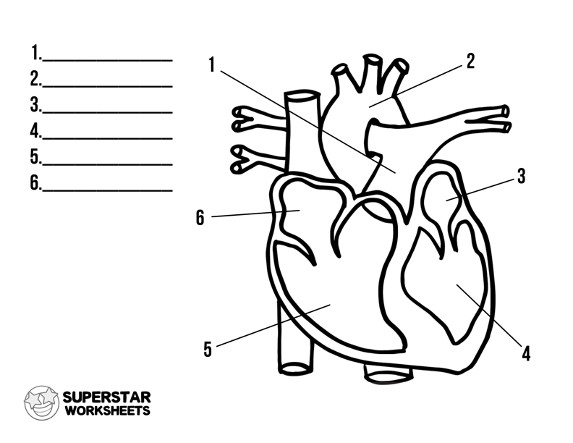

**1.**

**2.**

**3.**

**4.**

**5.**

**6.**

**What are the parts of the circulatory system?**

**Pulmonary circulation:**

**Systemic circulation:**

**THE LYMPHATIC SYSTEM**

**What is the lymphatic system?**

**What does the lymphatic system do?**

**COMPLETE THE DIAGRAM**

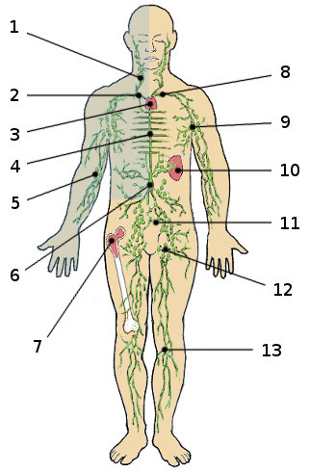

**KEY:**

|  |  |
| --- | --- |
| **1.** |  |
| **2.** |  |
| **3.** |  |
| **4.** |  |
| **5.** |  |
| **6.** |  |
| **7.** |  |
| **8.** |  |
| **9.** |  |
| **10.** |  |
| **11.** |  |
| **12.** |  |
| **13** |  |

**THE NERVOUS SYSTEM**

**What is the nervous system?**

**What are the parts of the nervous system?**

**How does the nervous system work?**

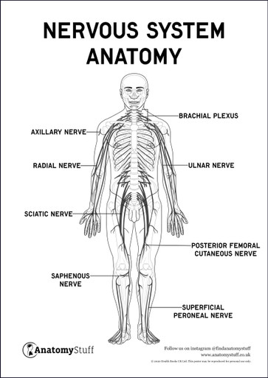

**THE DIGESTIVE SYSTEM**

**What is the digestive system?**

**What are the parts of the digestive system?**

**Give a detailed description of how the digestive system works?**

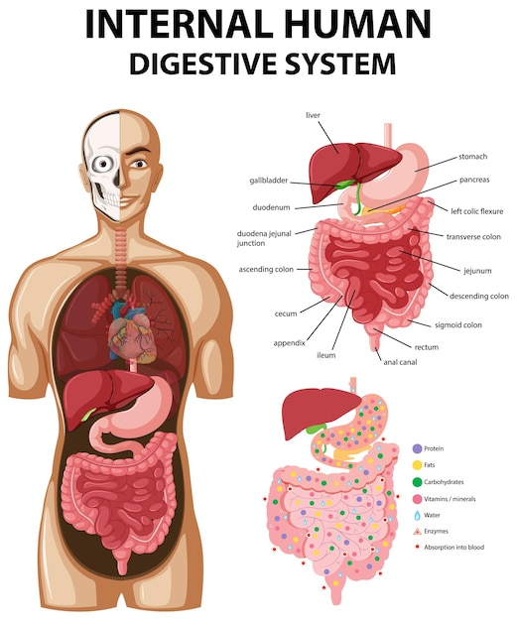

**THE URINARY SYSTEM**

**What is the urinary system?**

**What are the functions of the urinary system?**

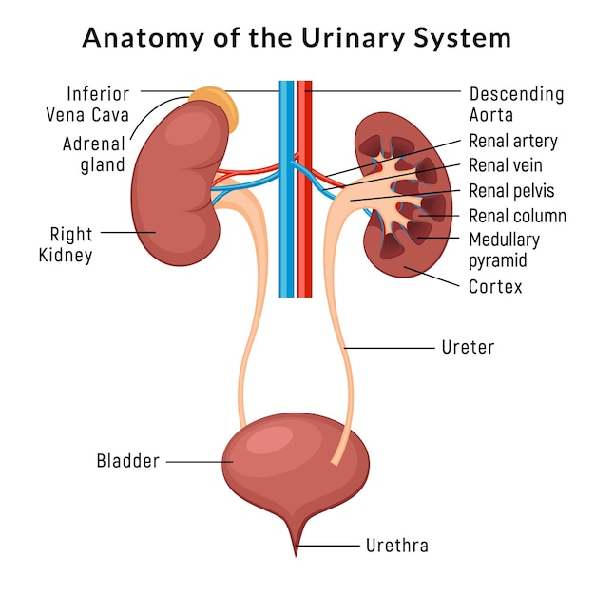

**THE ENDOCRINE SYSTEM**

**What is the Endocrine system?**

**What does the Endocrine system do?**

**What are the parts and the functions of the Endocrine system?**

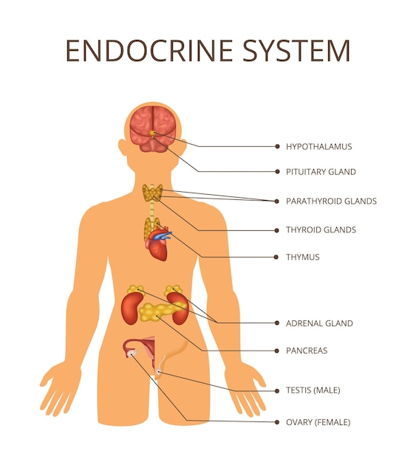

1. **Describe the main diseases of the main systems of the body:**
2. **Describe the effects of massage on the body**
3. **Describe the uses of five classical massage movements**
4. **Describe the uses of different massage mediums**
5. **Describe the legislation relating to the provision of massage treatments.**